NOS Admin Site Process Overview
Background
The NOS Admin site is a password-protected section used for adding NOS projects, inputting individual NOS & Welsh NOS and Supporting Documents. It also controls the approval workflows to allow review/rejection/approval of the projects and ultimately publishing of the resulting NOS documents on the public search site.
This document sets out the layout of the new NOS Admin site which supersedes the previous version and gives specific guidance on changes to logging-in, site navigation, creating Project Folders, inputting NOS & Welsh NOS and uploading Supporting Documents. The site has been developed using the existing approval and input processes and follows the same conventions and processes as before requiring 4-nation approval.
The Admin site is at this link; https://www.ukstandards.org.uk/en/admin
Log-in
The user details (e-mail, password & access permissions) are set-up by SDS and will allows access to specific folder/s as designated by S & F Panel with access managed by SDS. This site is used for the creation of folders and input of Project Details/NOS/Welsh NOS and Supporting Documents for approval.
The Admin site link will lead to a Sign-in page with e-mail and Password provided by SDS in advance. There is also a Forgotten your password function so registered users can gain access without 3rd party requests.
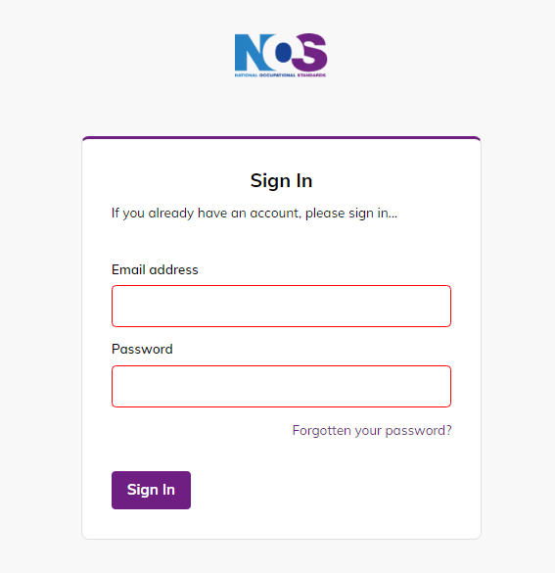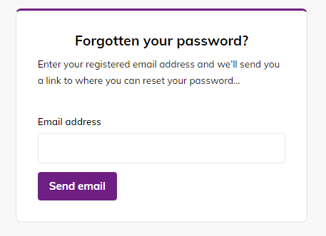
NOS Admin Portal Home
On successful log-in there is a landing page (screenshot below) which will contain supporting text, contact details and links to documents available. This is the first page everyone will see.
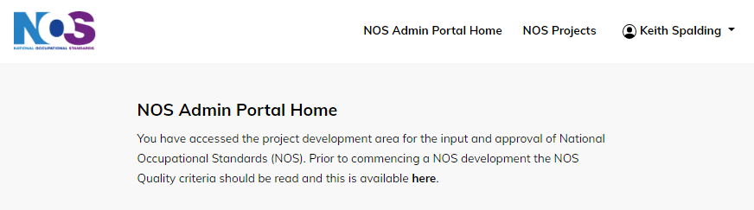
To view the projects available, click on the NOS Projects link on the toolbar. This will then direct you to the relevant projects that you have access to view.
Different access will be available depending on status of access and will be managed by SDS. Should you need access to another area for a project then contact SDS.
- Developers: Projects that Developers require access to, ie either their individual projects areas or those granted access to allow project work to be undertaken.
NOS Projects Admin Page
Title Current NOS Projects this contains a summary of live projects by Developer with current projects only showing on this page. The example below shows the layout with the Current projects being shown. All projects are available by clicking on the Developer name and will show Current and Approved Projects.
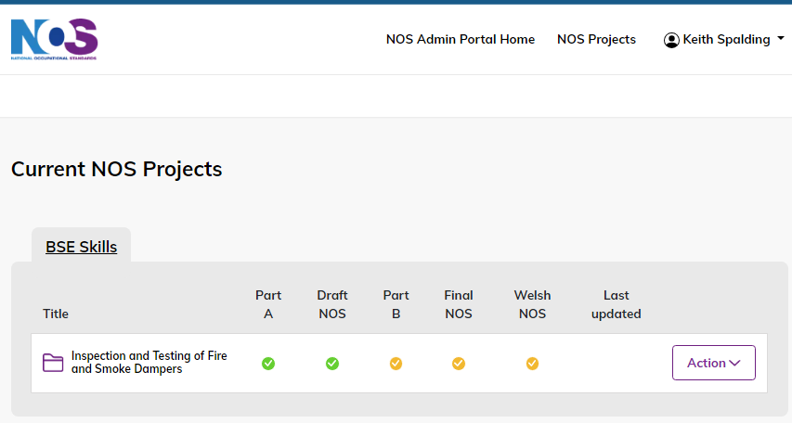
The colour coded dots show a summary of progress and are as follows:
- Green: Fully approved by all nations
- Amber: Awaiting submission by developer
- Blue: Submitted by developer for review by approver
- Red: New colour to signify where there has been a stage rejected by one or more nations, and awaiting update and resubmission by the Developer.
Individual Project information can be accessed by either clicking on the Folder Title, or select Edit in the Action button. The layout of the projects now brings everything together into a single project area as shown below.
Project Folder Layout
The individual project area now holds all the information related to developments. There are 3 separate areas within the project folder; Project Details, NOS Documents & Supporting Documents.
Project Details:
This area contains the content input, submission and approval processes for Part A, Draft NOS, Part B, Final NOS & Welsh NOS. These mirror the previous processes and nation specific requirements. When completed and approved there is a Green circle beside the area. The active section and nation are purple.
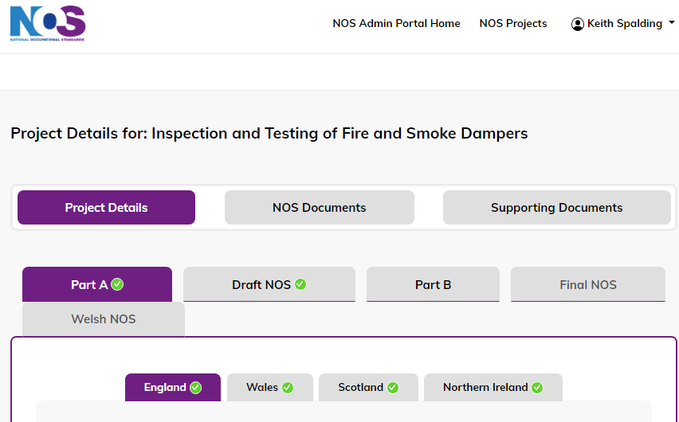
NOS Documents:
This area holds all the individual NOS documents and Welsh NOS which are entered using the New English NOS Document & New Welsh NOS Document buttons.
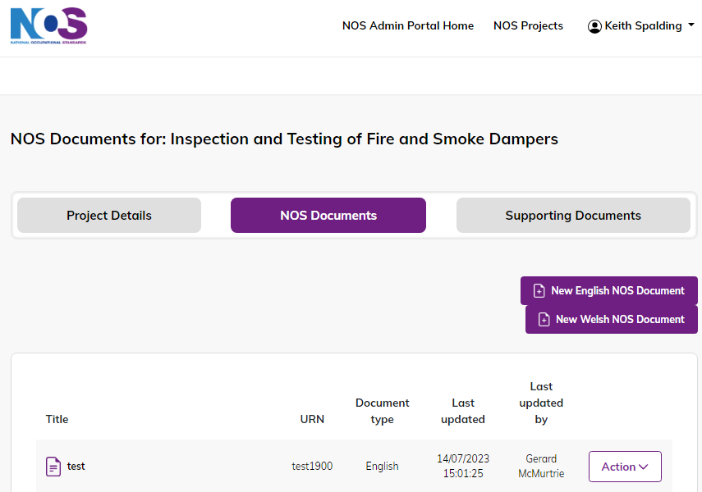
These open a form to allow details to be entered the same way as previously. The titles are in English & Welsh as shown below and there are asterisks beside mandatory fields. Formatting such as bold/italic/bullets and numbering is available in the input section.
To avoid any HTML formatting issues arising from copying directly from Word documents, when entering content ensure that that text is typed in or copied from Notepad. When copying text ensure copy clean text option is used if available.
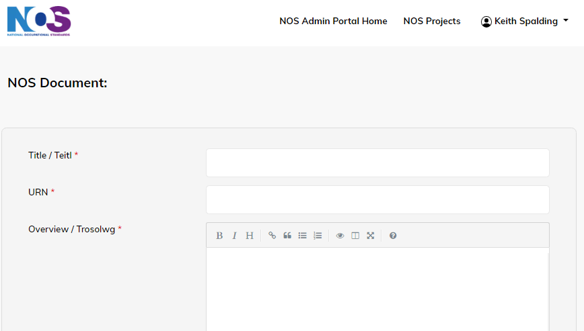
Once inputted the individual NOS & Welsh NOS documents are listed individually and can be opened by clicking on the NOS title or by selecting the options on the Action button. These are to either Edit, Duplicate, Preview as PDF or Delete.
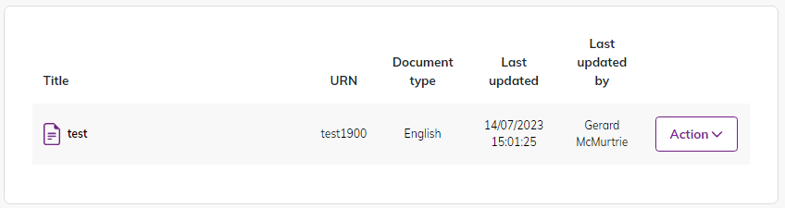
When using the Preview as PDF function this will open as a separate document, rather than in the web browser.
Supporting Documents:
This section acts as a repository for any documents required for the Project development process. This can include; Functional Map, Status of NOS document, Legacy request, Reports, Stakeholder engagement records, etc.
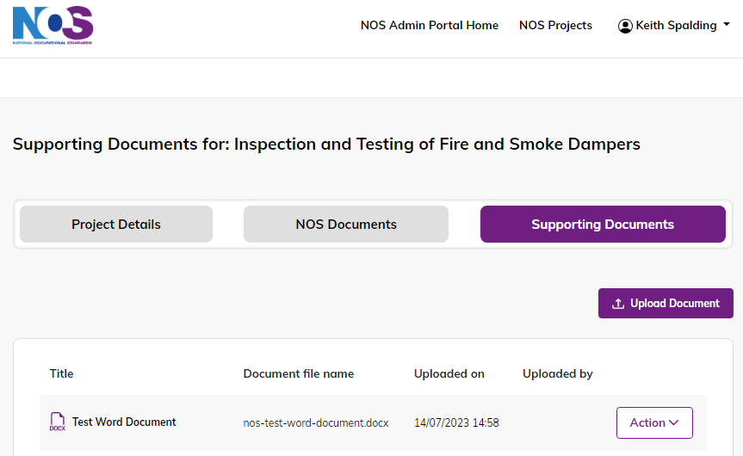
They can be uploaded in the chosen format by selecting Upload Document which bring the following screen up:
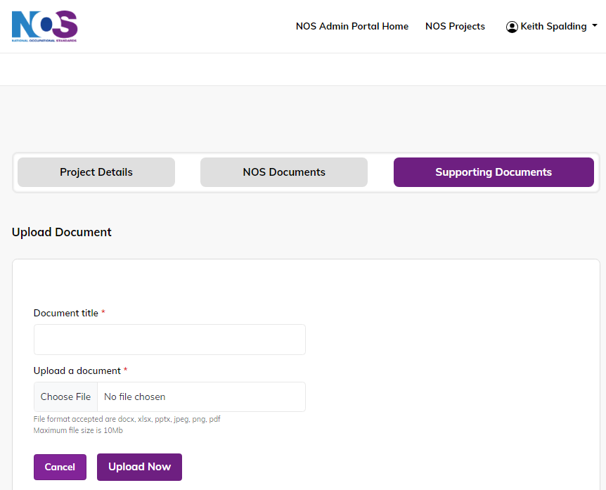
Project Completion & Publishing of NOS
Once a NOS Development Project has been completed it will disappear from the Current Projects list on the Admin Front page and Developer area and shows as an Approved Project. All projects are arranged chronologically.
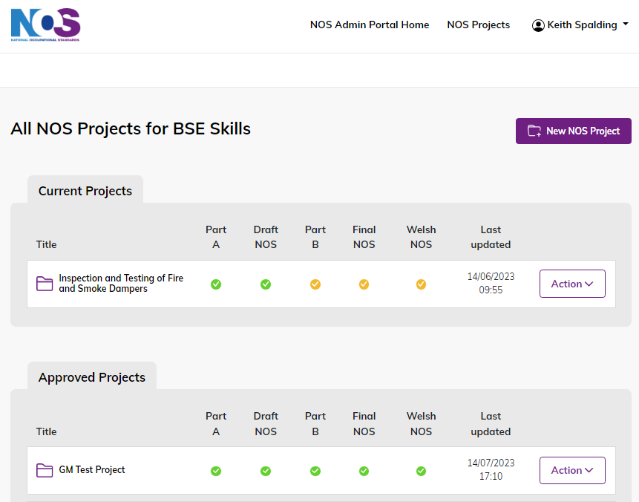
Once a project has been finally approved for NOS development and then subsequently Welsh NOS the respective NOS are automatically published and will be available on the search function at this link
https://www.ukstandards.org.uk/en/nos-finder

