Guide to using the NOS Finder

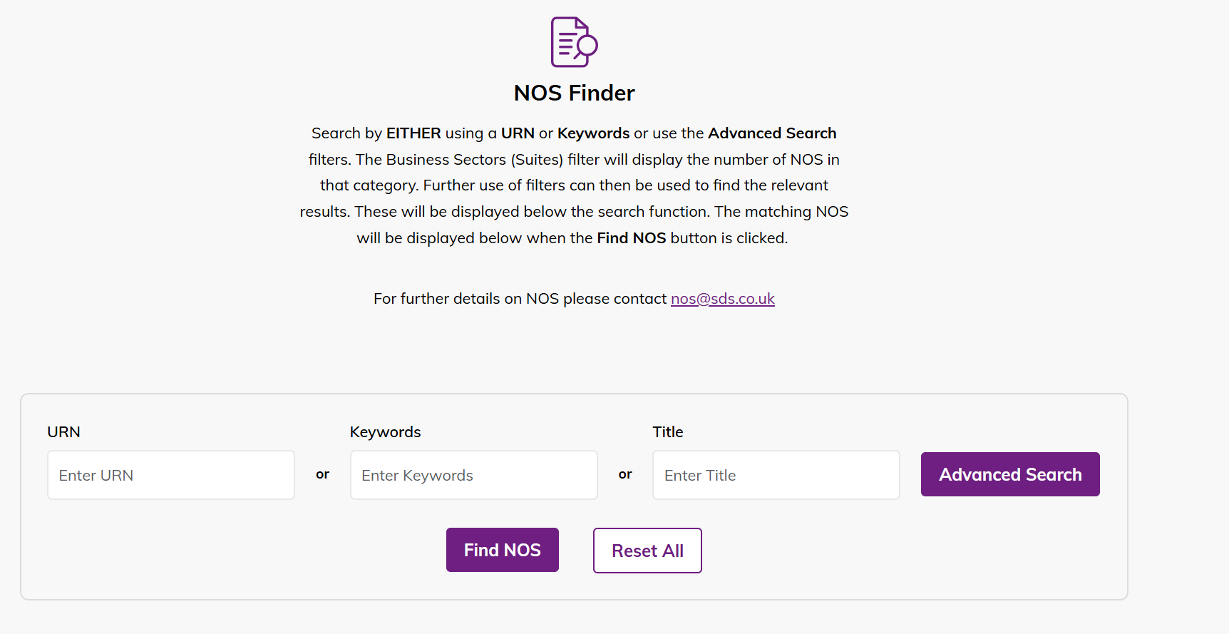

1. Basic Search
To conduct a basic search, enter any or one of the following fields, listed below in 1.1 and press the Find NOS button. To clear any existing searches, press the Reset All button.

1.1 Fields

Unique Reference Number (URN) field
This allows you to search by URN.

Keywords field
This allows you to search by the keywords and any other instance of the typed word used within the NOS document – e.g. all NOS that use the word “mechanical” in the body content.

Title field
This allows you to search for the title of the NOS.
- This also allows you to find NOS by certain titles, e.g. all NOS with “mechanical” in their titles.
With the search fields, you can use a combination of fields to further specify the search.
You can:
- Use the URN to search for a specific NOS – this field is case sensitive to the URN so this will not work if you want to search for a wide range of NOS that follows the same prefix e.g. LANLEO1-30
- Use keywords to search for all NOS containing a certain word – you can search for a NOS that uses the words “business”, “mechanical” etc. to search for NOS that uses an instance of that word – either in the body text or the keywords field.
  - Be careful since it can pick up parts of a word like “lean” that could be part of the word “clean”.
- The Title field allows you to search for the titles of a NOS. This can be helpful if you want to search for NOS related to a certain topic such as “cars” straightaway via the title.
You can mix and match these fields to further specify your searches.

1.2 Searching

Opening a NOS document
After conducting a search, this is what the results will look like below:
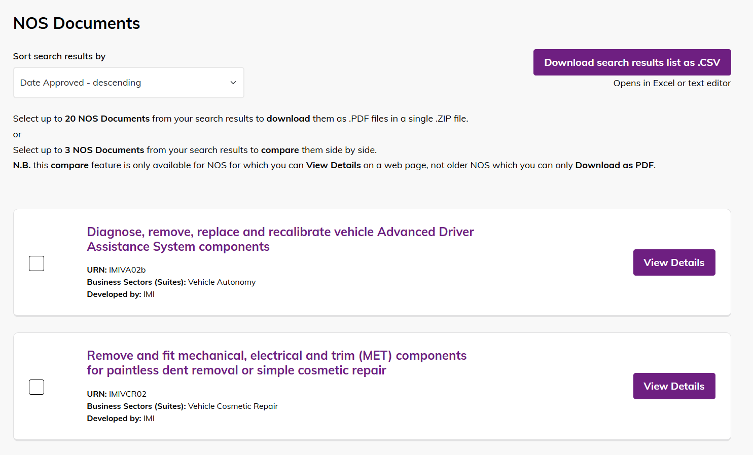
You can open the NOS document by clicking on the NOS title itself (purple text) or pressing the View details button.
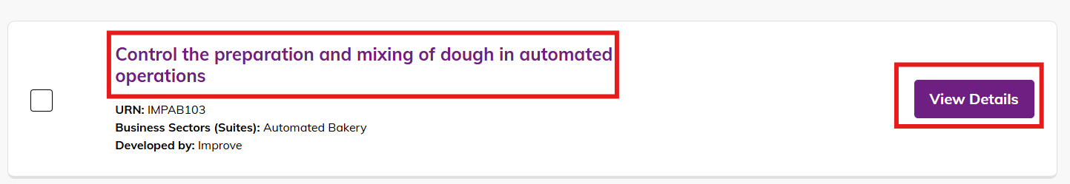
When opening the NOS, you are presented with the Title, followed by the URN, Business Sector (Suites), Developed By and Approved Dates of the NOS (more info regarding these can be read on page 8 or clicking on the respective links)
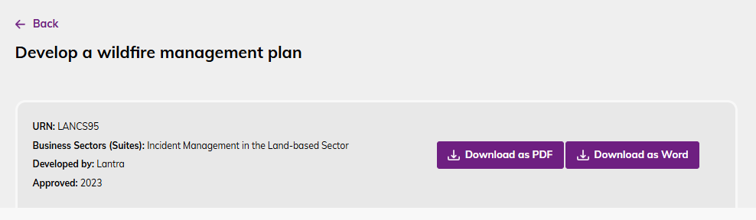
You will also be presented with the two buttons:

Download as PDF
This allows you to download the NOS document as a PDF.

Download as Word
This allows you to download the NOS document as a Word document.

Available in Welsh
Some NOS may also be available in Welsh which will allow you to open their Welsh equivalent – press the Available in Welsh button.
NOTE: Not all NOS documents are translated into Welsh.
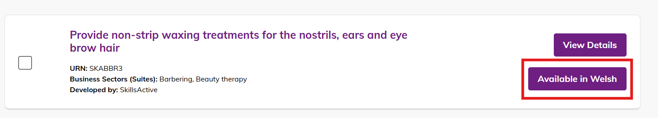
Additionally, the NOS site also has the option to switch to a Welsh version. This can be accessed via the CY button on the top navigation bar and can be switched back to the English site via EN button.
The search functions on the Welsh site functions the same as the English site.

Download as PDF
You may also encounter certain NOS that are available only as PDF, as indicated by the Download as PDF button as below. This will skip the typical opened NOS document page from before and open the PDF on your browser and gives the option to download as PDF.
Some NOS documents are only available as PDF provided by developers. These are often for Legacy NOS (more info below on page 9 or click here), or NOS that are older and have not been formally added as a document on the site, so they are only available via PDF format.
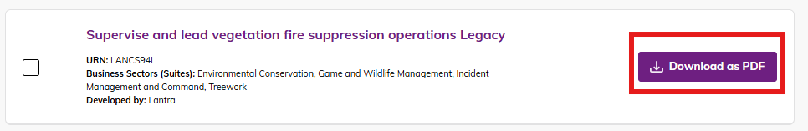

Download Search Results as .CSV file
The search results list can be exported as a Comma Separated Values (CSV) file (an excel spreadsheet).
To do this, simply click on the Download search results list as CSV button.
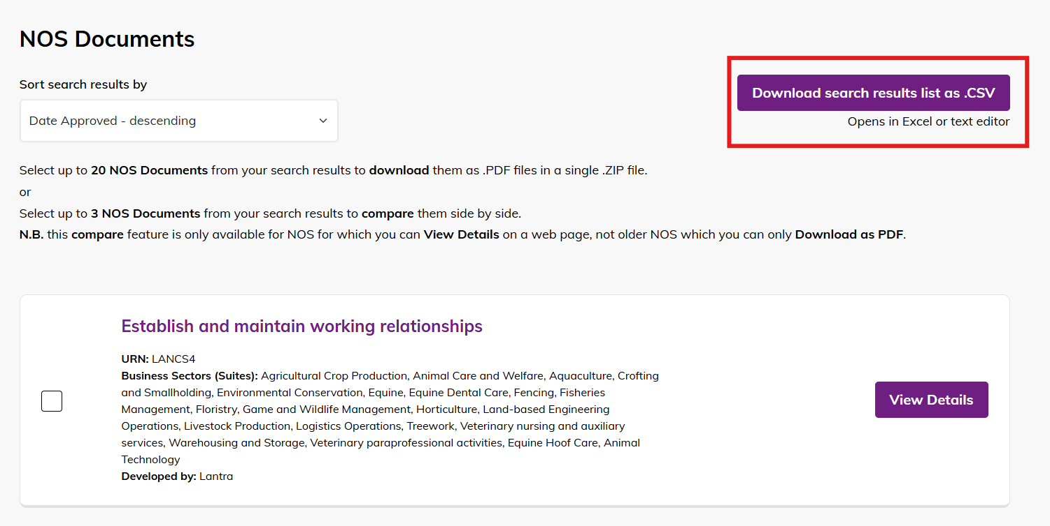
This will automatically download the CSV file which you can open from the Downloads folder
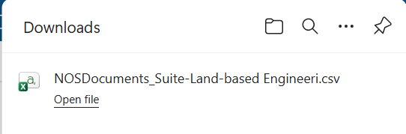
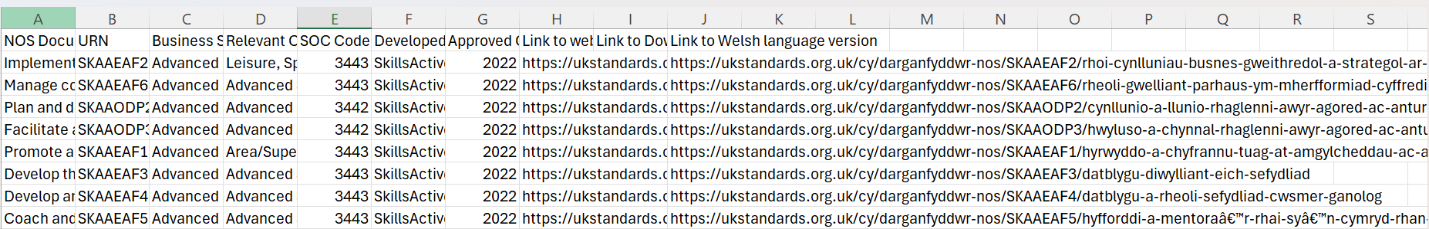

Compare NOS Documents
From the search results list, you can also compare up to three different NOS documents in terms of the content
To do this simply:
Click on the small tick box on the left of the NOS selection
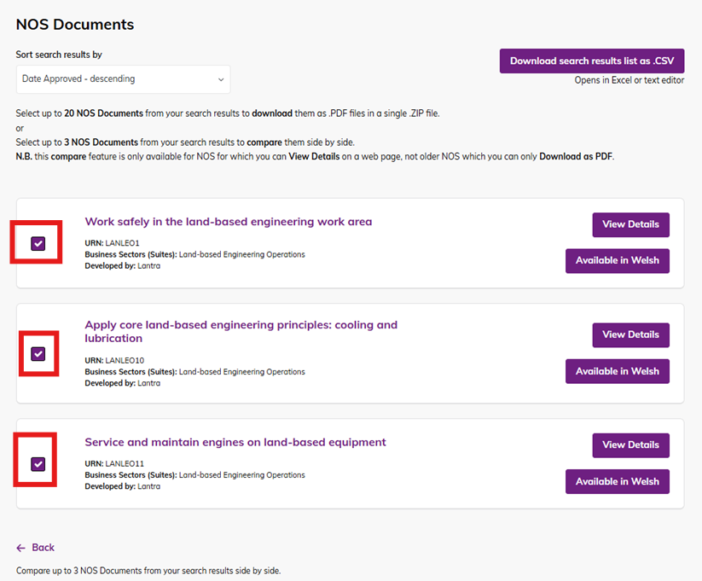
Selecting an NOS using the checkbox will display a purple bar with the available actions:

Download selected NOS as a .ZIP
When you select one or more NOS documents, you can download them together as a single ZIP file. This lets you choose and download only the NOS you need, rather than downloading the entire list.

Clear Selection
Clear your current selection so you can start again.
Compare
Allows you to compare the NOS you’ve selected. This option appears when more than one NOS is selected. You can compare up to three NOS at a time.
When you select Compare, a new screen will appear showing a side‑by‑side comparison of the selected NOS.
Each NOS is broken down by sections such as Overview, Performance Criteria, and other key areas.
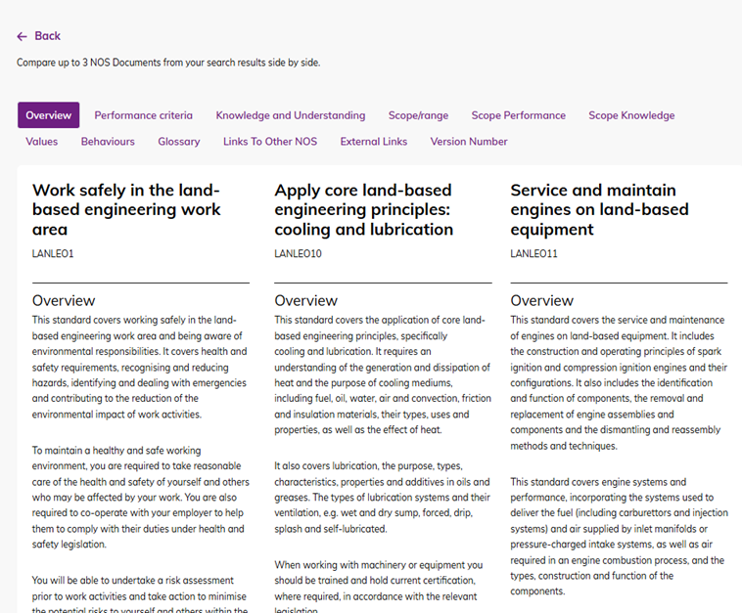

2. Advanced Search
Besides Basic Search, Advanced Search lets you use filters for more specific results. This can be accessed via the Advanced Search button
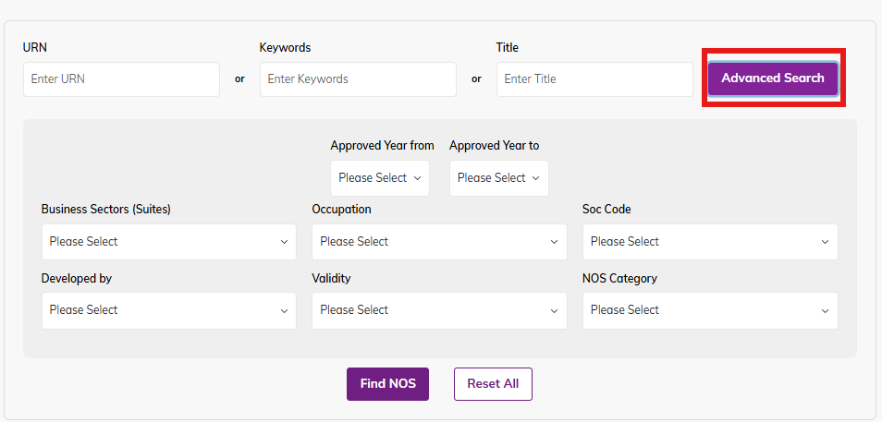

2.1 Dropdown overviews
After clicking on the Advanced Search button, this allows you to then filter and specify your search with the following dropdowns:

Business Sectors (Suites)
This allows you to search the Suites that the NOS sits under. e.g. Automotive Glazing.
The dropdown list also states the number of NOS that currently sit under the suite – for example there are 21 NOS that sit under Automotive Glazing suite – these can be a mix of Current and Legacy NOS (more info below on page 9 or click here). This number is shared across all the dropdown lists.
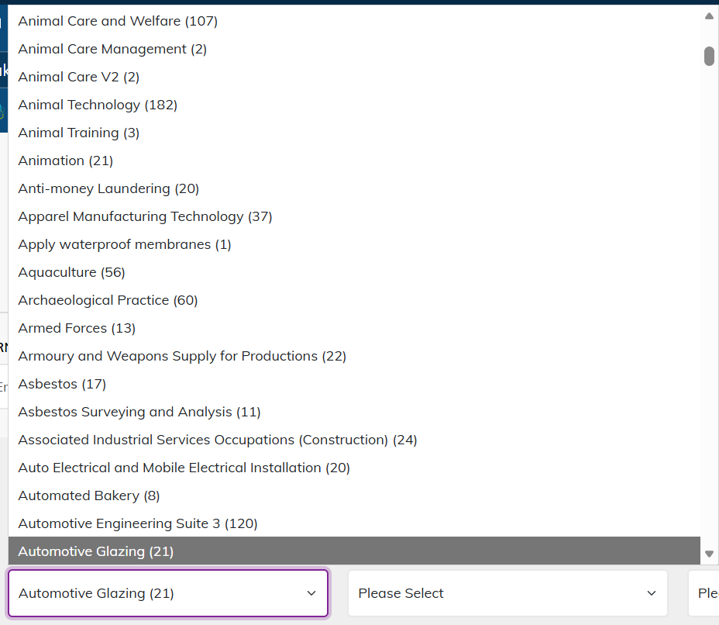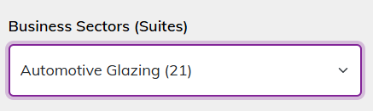

Occupation
This allows you to search for the Occupations that are associated with the NOS. Some NOS may have multiple occupations listed in their field, so this will also pull those as well.
e.g. all the NOS that have Account Receivable Manager as listed Occupation.
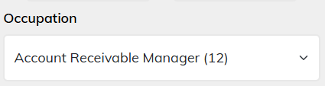

SOC Code
This allows you to search for the SOC code of the NOS. Certain NOS documents under a common suite/ occupation will have the same series of SOC codes.
e.g. all the SFTT NOS sit under the SOC code 1172
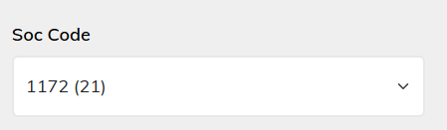

Developed By
This allows you to filter the Developers of the NOS.
e.g. all the NOS developed by Lantra.
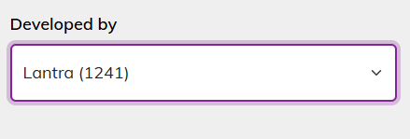

Validity
This allows you to search and filter by the validity status of the NOS. There are two NOS statuses:

Current
These are NOS which are currently used and Live. These should be considered the most up to date version.

Legacy
These are NOS which are considered older and may have been replaced by newer NOS. They may also be the previous version.
These remain on the database as they may still be used in current qualifications. There is a form on the NOS database that NOS developers should complete if they wish NOS to be made legacy.
- These are indicated by an L suffix at the end of the URN. e.g. LANLEO6L
- The legacy NOS that are considered obsolete and no longer in use are to be archived/ or deleted which would result in their removal from the database. Legacy NOS still has some usages by their developers, and as such would remain in the database for a purpose. SDS periodically carry out archiving exercises with NOS developers, to remove NOS, which are no longer in use.
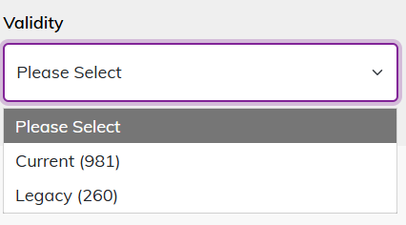

NOS Category
This allows you to search for NOS based on categories.
There are three categories at which a developer would select their NOS to sit under:
- Core
- Generic
- Job Specific
This would depend on the type of NOS, content, and usage of the developer.
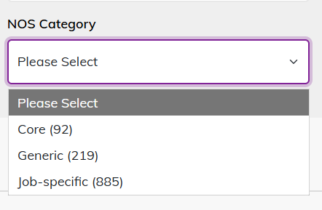

Approved Year From/To
This allows you to search for NOS that has been approved from a specified year to their indicative review date. When the NOS document is being added to the database, the requirement is that the indicative review date needs to be at least a year after the approved date.
e.g. all the NOS that were approved from 2019 and to be reviewed in 2024.
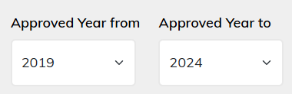

3. Working example of a search
From this, users can perform even more specific search using a combination of filters for a specific search.
Here is an example below of NOS that were developed by Lantra, from the Crofting and Smallholding suite, that are Current and Job specific – from the years 2019-2024:
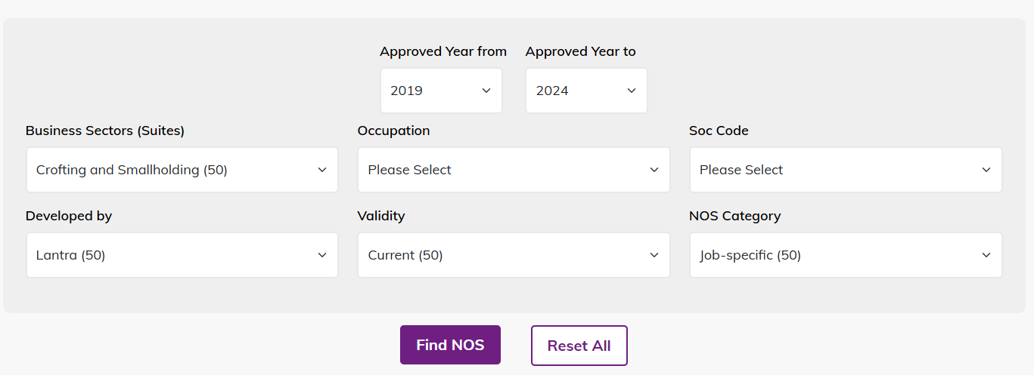
With this search, a list of 50 NOS is produced.
If more filter dropdowns are selected, it would even specify further and narrow down the search number even more. The selection of the dropdown would update depending on what other fields have been selected
For instance, when clicking on the SOC code – the options on the dropdown list would narrow down even further based on what has been selected and show a limited list of option which would further narrow this list as per the numbers sitting under the SOC code which follow the previous search filter criteria.
In this example, SOC Code 5119 is added to the search; this would narrow down the list to 27 NOS, further specifying the search results list with the specific NOS searched.
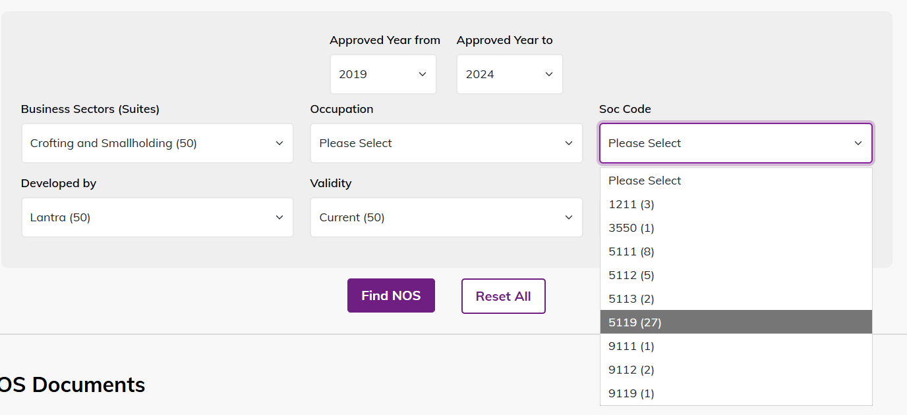
Feel free to mix and match specific fields and information for more selective lists and results.

4. Glossary of Terms
National Occupational Standard (NOS):
A statement of the standard of performance an individual must achieve when carrying out a function in the workplace, together with a specification of the underpinning knowledge and understanding.
- NOS are National because they can be used in every part of the UK where the function is carried out.
- NOS are Occupational because they describe the performance required of an individual when carrying out the functions in the workplace, i.e., in their occupation (as a plumber, police officer, production engineer etc).
- NOS are Standards because they are statements of effective performance which have been agreed by a representative sample of employers and other key stakeholders and approved by the Standards & Frameworks Panel.
NOS Database:
The central database contains all current NOS, developed by all Standards Setting Organisations.
URN:
Refers to “Unique Reference Number” - A unique number given to each NOS which comprises a prefix indicating the Standards Setting Organisation, which has developed the NOS and a suffix indicating the position of the NOS in the functional map or suite.
Business Suite:
Set of related NOS which covers all the functions required for a sector, occupation, or area or work.
Occupation:
A specific type of work carried out by an individual as defined by relevant Standard Occupational Classification.
SOC Code:
SOC refers to “Standard Occupational Classification” - a common classification of occupational information for the UK.
- The SOC Code is a standard number used to group NOS.
  - NOS can be linked to one or more SOC Codes where standards apply to multiple related occupations.
Legacy NOS:
A NOS which has been superseded by new or revised NOS but is still used in qualifications.
Current NOS:
These are NOS which are currently used and live. These should be considered the most up to date version.

